Full Paper Title in Title Case

Author One ¹, Author Two* ², Author Three ³

¹ Affiliation
² Affiliation
³ Affiliation
*Corresponding author: email address

ABSTRACT
Abstract-This file provides a standard template for writing full papers for the conference. All text use Times New Roman style, font size 11, single spacing, 1 column for abstract, 2 columns for main text. The abstract should contain the essence of your work in not more than 200 words. It should be a single paragraph written in past tense. The abstract should answer the following questions: Motivation: Why do we care about this topic? Problem statement: What is the main issue that you are going to address? Methodology: What kind of specimens were used? How many specimens were tested and how? Results: What were the experimental outputs? Implications: How does this work add to the body of knowledge on the topic?

Keywords - About six key words or phrases separated by commas.

INTRODUCTION
This section should introduce the topic and set it in the broader context. The topic should then be gradually narrowed down to the research problem and how you mean to solve the research problem. It should make the reader want to know further. The introduction should generally provide information on the following: existing knowledge, limitations/conflicts in the knowledge, need for the study, problems investigated, hypotheses tested and structure of the extended abstract. While referring to previous work, references should be numbered consecutively in the text, and the citation number should be enclosed in square brackets (for example, [1]). The sentence punctuation should follow the bracket [2]. When citing a reference in the text, refersimply to the reference number, “as in [3]”. Do not use“Ref. [3]” or “reference [3]” except at the beginning of a sentence:“Reference [3] was the first….”.
It is expected that authors will submit carefully written and proofread material with similarity index below 30%. Spelling and grammatical errors, as well as language usage problems, are not acceptable. There is no strict limitation to the number of pages, but it is suggested that the paper length should not exceed 7 pages.

Papers should clearly describe the background of the subject, the authors work, a problem statement, including the methods used, and concluding discussion on the importance of the work. Papers are to be prepared in English (British or American) and SI-units shall be used. Technical terms should be explained unless they may be considered to be known to the broader nuclear community. Acronyms should be written out at their first appearance.

RESEARCH SIGNIFICANCE
The impact of the findings should be explained in about 70 words. The answer for how this work will solve the existing problem should be given. Clearly state how the paper closes the gaps stated in the introduction. If any new method or novel technique had been used, clearly elaborate the merits.

MATERIAlS AND METHODS
This section should clearly describe what was actually done. It should be presented in a narrative format as paragraphs and should not contain any results. Use subheads when more than one experiment has been done.

Sub-heading
What are the details that can be included? Provide necessary quantitative details while describing the materials like how much, how long, composition etc. The experimental design should be clearly described. The treatments, controls and measured variable should be specified. A drawing/ image of the experimental set up should be added. If an unconventional setup or method had been used, give an adequate description. If a field investigation had been done, mention when and where it was conducted.

RESULTS AND DISCUSSION
This section is considered as the most important section of the full paper and demonstrates the contribution of the presented work. It is not just an objective report of information. It comprises of new findings that are being presented to the scientific community and the author’s comments on the obtained results. Also, the theoretical and practical implications of the obtained results have to be discussed. The author should clearly mention if there is an agreement or disagreement with any previous finding. Possible directions for future research on similar subjects, can be provided.

Position of figure and table
Figure captions should be below the figures. Table heads should appear above the tables. Insert figures and tables after they are cited in the text. Use the abbreviation “Fig. 1”, even at the beginning of a sentence.

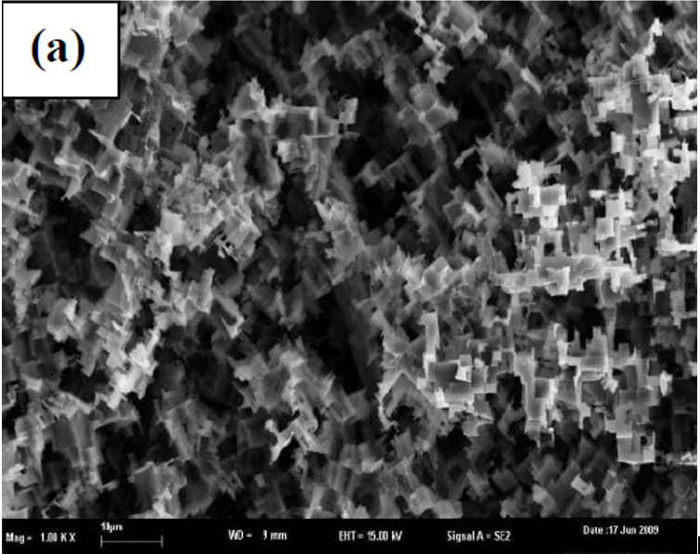

Figure1. Caption style for describing figures

Table 1. Table type styles

Table Head | Table Column Head
 | Table column subhead | Subhead | Subhead

Equations should be included in the text in the following format.

a + b = c Eq. (1)

Eq. (2)

The symbols in the equation should be defined either before the equation appears or immediately following it. Represent the equation as “Equation 1” in the text.

In general, use a zero before decimal points: “0.25,” not “.25.” Use “cm³,” not “cc.” Do not mix complete spellings and abbreviations of units: “Wb₂/m²” or “webers per square meter,” not “webers/m².” Spell units when they appear in text: “…a few henries,” not “…a few Henries,” not”...a few H.”

CONCLUSION
This section should provide an overall insight into the theories presented in the paper. Everything stated in the paper early should support the conclusion and smoothly lead to it. In short, the conclusion should stress the importance of the problem statement, give the extended abstract a sense of completeness and leaves a final impression on the reader.

ACKNOWLEDGEMENTS
Include your acknowledgements here if you wish to identify funding sources or significant contributions by others.

REFERENCES
Use IEEE Reference Style. Reference font is 10pt. Reference should not more than 20.

[1] B. J. Usman and S. A. Ali, “Carbon Dioxide Corrosion Inhibitors: A review,” Arab. J. Sci. Eng., vol. 43, no. 1, 2018, doi: 10.1007/s13369-017-2949-5.
[2] F. Straetmans, Udo Straetmans, Marko Soltau, “Polymeric corrosion inhibiter for metal surfaces and the production thereof,” US Pat. App.14/000, 772, vol. 1, no. 19, 2012, doi: 10.1016/j.(73).
[3] C. Jeyaprabha, S. Sathiyanarayanan, and G. Venkatachari, “Polyaniline as corrosion inhibitor for iron in acid solutions,” J. Appl. Polym. Sci., vol. 101, no. 4, pp. 2144–2153, 2006, doi: 10.1002/app.22579.
[4] F. Farelas, M. Galicia, B. Brown, S. Nesic, and H. Castaneda, “Evolution of dissolution processes at the interface of carbon steel corroding in a CO2 environment studied by EIS,” Corros. Sci., vol. 52, no. 2, pp. 509–517, 2010, doi: 10.1016/j.corsci.2009.10.007.
[5] F. G. Liu, M. Du, J. Zhang, and M. Qiu, “Electrochemical behavior of Q235 steel in saltwater saturated with carbon dioxide based on new imidazoline derivative inhibitor,” Corros. Sci., vol. 51, no. 1, pp. 102–109, 2009, doi: 10.1016/j.corsci.2008.09.036.
[6] P. C. Okafor, X. Liu, and Y. G. Zheng, “Corrosion inhibition of mild steel by ethylamino imidazoline derivative in CO2-saturated solution,” Corros. Sci., vol. 51, no. 4, pp. 761–768, 2009, doi: 10.1016/j.corsci.2009.01.017.
[7] M. W. S. Jawich, G. A. Oweimreen, and S. A. Ali, “Heptadecyl-tailed mono- and bis-imidazolines: A study of the newly synthesized compounds on the inhibition of mild steel corrosion in a carbon dioxide-saturated saline medium,” Corros. Sci., vol. 65, pp. 104–112, 2012, doi: 10.1016/j.corsci.2012.08.001.
[8] M. P. Desimone, G. Gordillo, and S. N. Simison, “The effect of temperature and concentration on the corrosion inhibition mechanism of an amphiphilic amido-amine in CO2 saturated solution,” Corros. Sci., vol. 53, no. 12, pp. 4033–4043, 2011, doi: 10.1016/j.corsci.2011.08.009.
[9] J. Zhao and G. Chen, “The synergistic inhibition effect of oleic-based imidazoline and sodium benzoate on mild steel corrosion in a CO 2-saturated brine solution,” Electrochim. Acta, vol. 69, pp. 247–255, 2012, doi: 10.1016/j.electacta.2012.02.101.
[10] A. Hamdy and N. S. El-Gendy, “Thermodynamic, adsorption and electrochemical studies for corrosion inhibition of carbon steel by henna extract in acid medium,” Egypt. J. Pet., vol. 22, no. 1, pp. 17–25, 2013, doi: 10.1016/j.ejpe.2012.06.002.
[11] E. A. Noor and A. H. Al-Moubaraki, “Thermodynamic study of metal corrosion and inhibitor adsorption processes in mild steel/1-methyl-4[4′(-X)-styryl pyridinium iodides/hydrochloric acid systems,” Mater. Chem. Phys., vol. 110, no. 1, pp. 145–154, 2008, doi: 10.1016/j.matchemphys.2008.01.028.

